2019 MCREA Golf Tournament Hotels

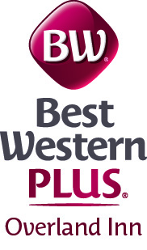
1410 Barlow Rd, Fort Morgan, CO 80701
(970) 370-2322
$119.99 per night
$129.99 for a suite

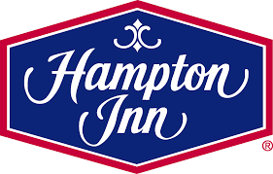
1152 Main Street, Fort Morgan, CO 80701
(970) 542-2484
$139 per night

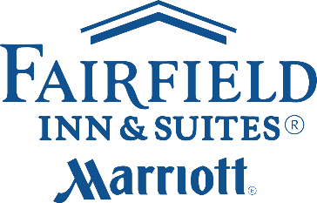
1290 Cottonwood Parkway, Fort Morgan, CO 80701
(970) 441-6200
$149 per night

